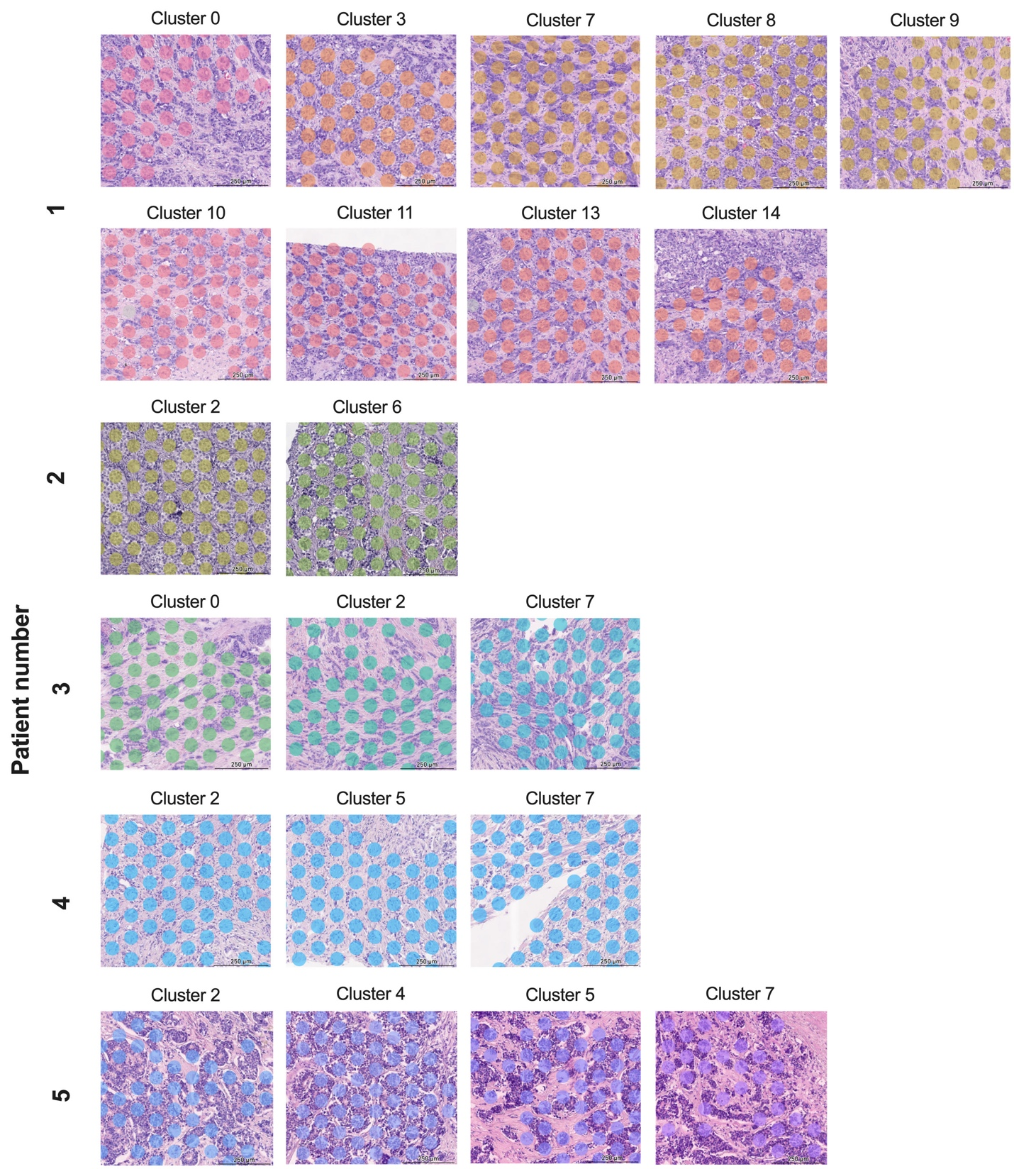
Supplementary Fig. 1. Projection of all studied clusters on each sample tissue slides.

